JENKINS CHALLENGES
Use the below code and implement our CICD stages.
- Source Code:https://github.com/betawins/hiring-app.git
  - Repository contains the application code for the hiring app.
- Create one Declarative pipeline job
Create new item →select pipeline →save
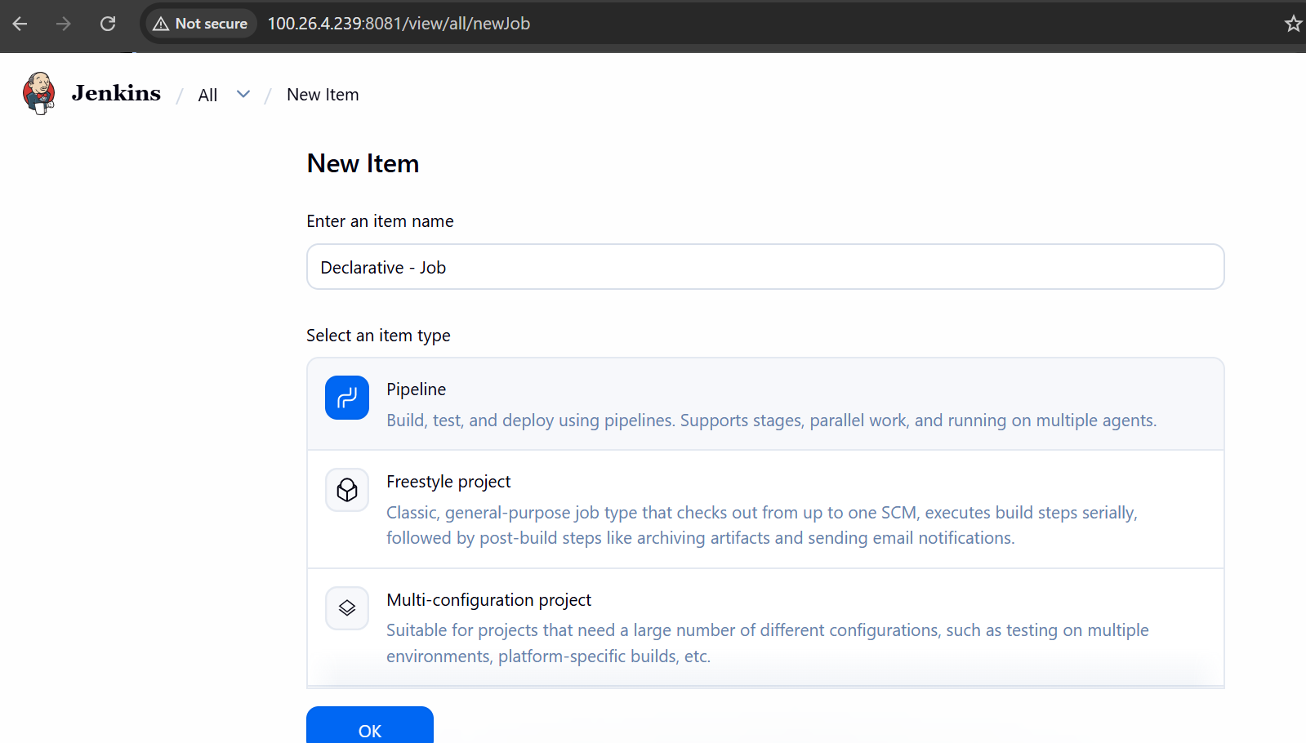
Open job→ click on configure→ write pipeline →save& build
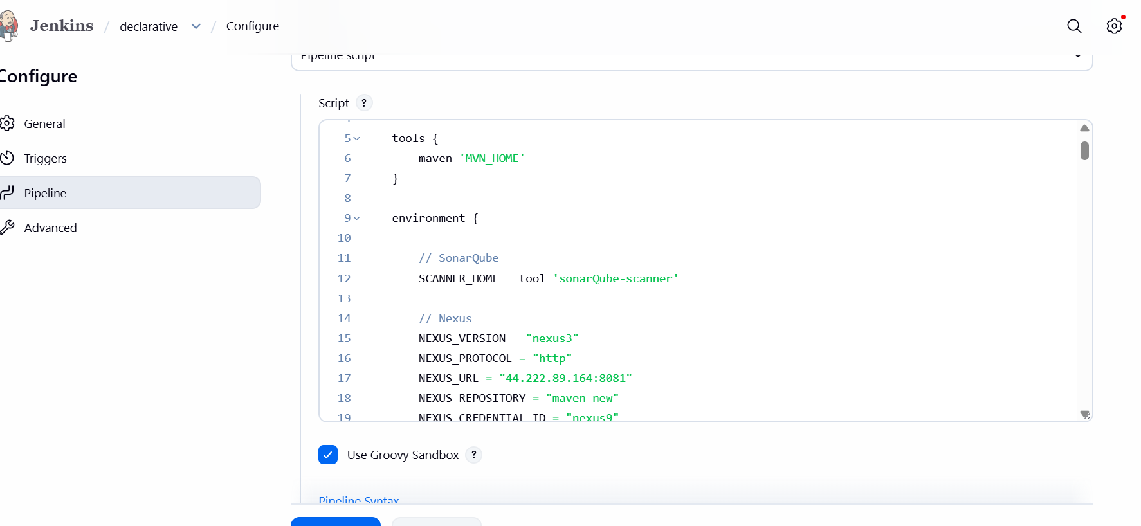
Used below script for pipeline
pipeline {

agent any

tools {
maven 'MVN_HOME'
}

environment {

// SonarQube
SCANNER_HOME = tool 'sonarQube-scanner'

// Nexus
NEXUS_VERSION = "nexus3"
NEXUS_PROTOCOL = "http"
NEXUS_URL = "44.222.89.164:8081"
NEXUS_REPOSITORY = "maven-new"
NEXUS_CREDENTIAL_ID = "nexus9"

// Artifact Details
GROUP_ID = "in.javahome"
ARTIFACT_ID = "hiring"
VERSION = "1.0.${BUILD_NUMBER}-SNAPSHOT"

// Tomcat
TOMCAT_URL = "http://98.92.60.63:8080/"
TOMCAT_CREDENTIAL_ID = "tomcat-server"

// Slack
SLACK_CHANNEL = "all-hemanth"

// Email
EMAIL_RECIPIENT = "hemanthsalapu126@gmail.com"
}

stages {

stage('Clean Workspace') {
steps {
cleanWs()
}
}

stage('Clone Source Code') {
steps {

git branch: 'main',
url: 'https://github.com/betawins/hiring-app.git'
}
}

stage('Build Application') {
steps {

sh "${tool 'MVN_HOME'}/bin/mvn clean install"
}
}

stage('Run Unit Tests') {
steps {

sh 'mvn test'
}
}

stage('SonarQube Code Analysis') {

steps {

withSonarQubeEnv('sonarQube') {

sh """
${SCANNER_HOME}/bin/sonar-scanner \
-Dsonar.projectKey=hiring-app \
-Dsonar.projectName=hiring-app \
-Dsonar.sources=.
"""
}
}
}

stage('Package Application') {

steps {

sh 'mvn clean package'
}
}

stage('Archive Artifact') {

steps {

archiveArtifacts artifacts: 'target/hiring.war'
}
}

stage('Upload WAR to Nexus') {

steps {

nexusArtifactUploader(

nexusVersion: NEXUS_VERSION,
protocol: NEXUS_PROTOCOL,
nexusUrl: NEXUS_URL,
repository: NEXUS_REPOSITORY,
credentialsId: NEXUS_CREDENTIAL_ID,
groupId: GROUP_ID,
version: VERSION,

artifacts: [
[
artifactId: ARTIFACT_ID,
classifier: '',
file: 'target/hiring.war',
type: 'war'
]
]
)
}
}

stage('Deploy to Tomcat') {

steps {

deploy adapters: [
tomcat9(
credentialsId: TOMCAT_CREDENTIAL_ID,
path: '',
url: "${TOMCAT_URL}"
)
],

contextPath: 'hiring-app',
war: 'target/hiring.war'
}
}
}

post {

success {

// Slack Notification
slackSend(
channel: "${SLACK_CHANNEL}",
color: 'good',
message: """
SUCCESS:
Job Name: ${env.JOB_NAME}
Build Number: ${env.BUILD_NUMBER}
Build URL: ${env.BUILD_URL}
"""
)

// Email Notification
mail(
to: "${EMAIL_RECIPIENT}",
subject: "SUCCESS: ${env.JOB_NAME} Build #${env.BUILD_NUMBER}",
body: """
Hello Team,

Jenkins Pipeline executed successfully.

Job Name : ${env.JOB_NAME}
Build Number: ${env.BUILD_NUMBER}
Build URL : ${env.BUILD_URL}
Status : SUCCESS

Regards,
Jenkins
"""
)
}

failure {

// Slack Notification
slackSend(
channel: "${SLACK_CHANNEL}",
color: 'danger',
message: """
FAILED:
Job Name: ${env.JOB_NAME}
Build Number: ${env.BUILD_NUMBER}
Build URL: ${env.BUILD_URL}
"""
)

// Email Notification
mail(
to: "${EMAIL_RECIPIENT}",
subject: "FAILED: ${env.JOB_NAME} Build #${env.BUILD_NUMBER}",
body: """
Hello Team,

Jenkins Pipeline execution failed.

Job Name : ${env.JOB_NAME}
Build Number: ${env.BUILD_NUMBER}
Build URL : ${env.BUILD_URL}
Status : FAILURE

Please check Jenkins console logs.

Regards,
Jenkins
"""
)
}
}
}
Build successfully
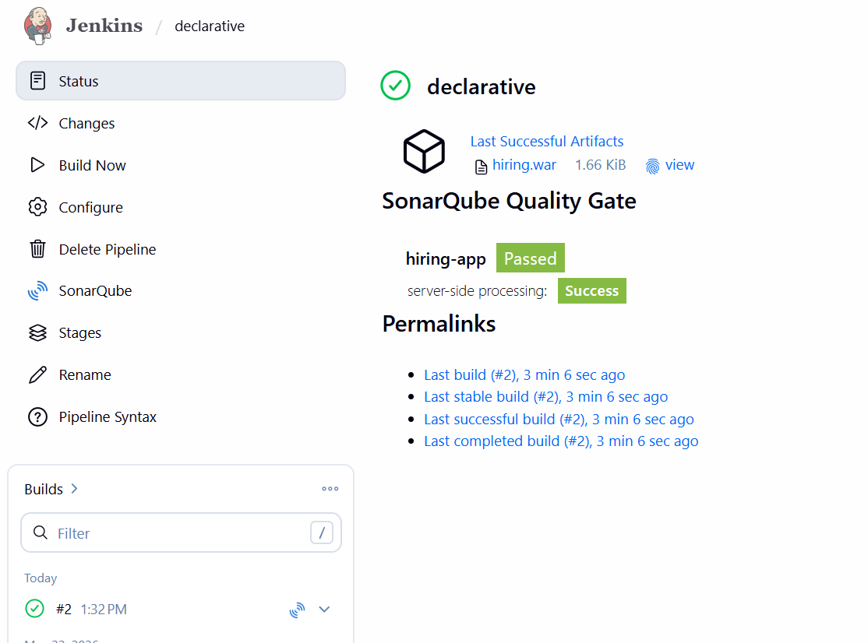
Console output
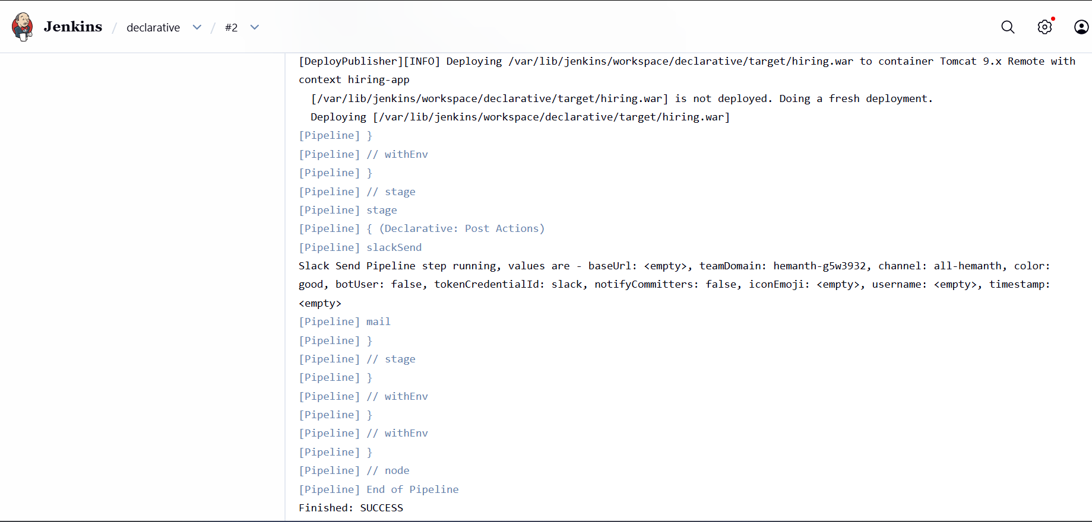
Slack notification
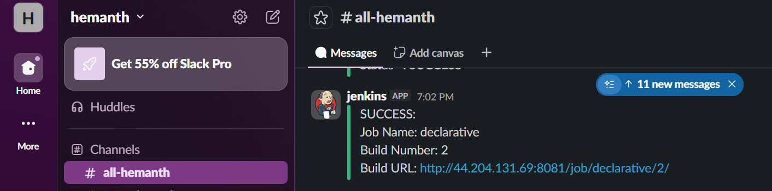
Email notification
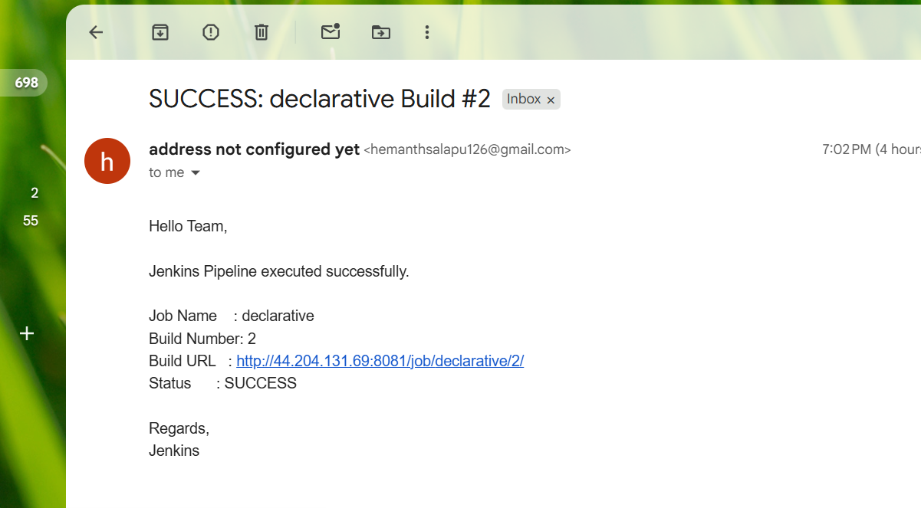
- Create one Scripted pipeline job
Create new item→ select pipeline →save
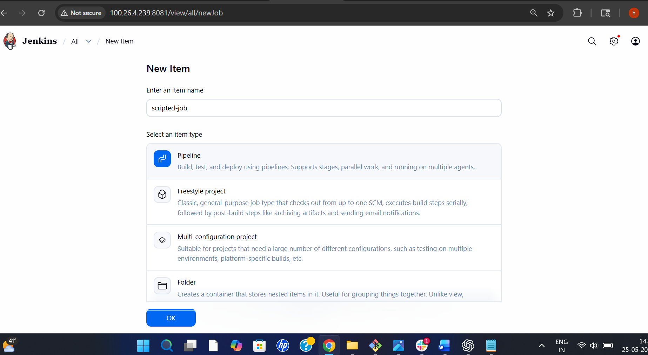
Open job→ click on configure →write pipeline →save& build
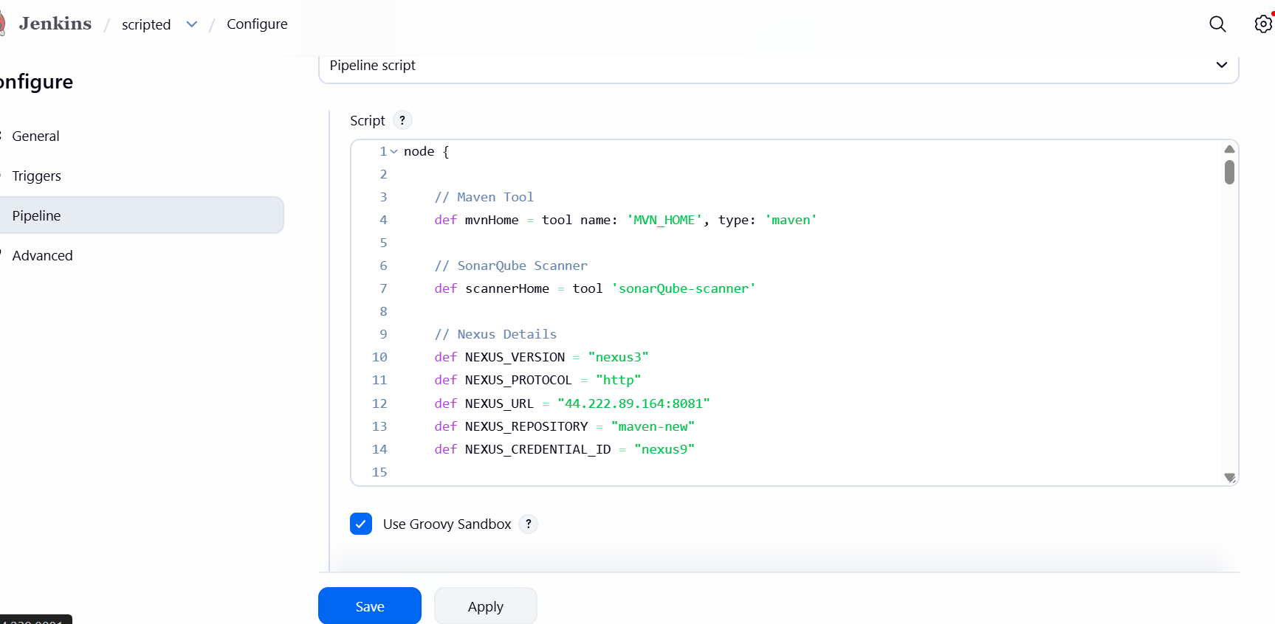
Used below script for pipeline
node {

// Maven Tool
def mvnHome = tool name: 'MVN_HOME', type: 'maven'

// SonarQube Scanner
def scannerHome = tool 'sonarQube-scanner'

// Nexus Details
def NEXUS_VERSION = "nexus3"
def NEXUS_PROTOCOL = "http"
def NEXUS_URL = "44.222.89.164:8081"
def NEXUS_REPOSITORY = "maven-new"
def NEXUS_CREDENTIAL_ID = "nexus9"

// Artifact Details
def GROUP_ID = "in.javahome"
def ARTIFACT_ID = "hiring"
def VERSION = "1.0.${env.BUILD_NUMBER}-SNAPSHOT"

// Tomcat Details
def TOMCAT_URL = "http://98.92.60.63:8080/"
def TOMCAT_CREDENTIAL_ID = "tomcat-server"

// Slack Channel
def SLACK_CHANNEL = "all-hemanth"

// Email Recipient
def EMAIL_RECIPIENT = "hemanthsalapu126@gmail.com"

try {

stage('Clean Workspace') {

cleanWs()
}

stage('Clone Source Code') {

git branch: 'main',
url: 'https://github.com/betawins/hiring-app.git'
}

stage('Build Application') {

sh "${mvnHome}/bin/mvn clean install"
}

stage('Run Unit Tests') {

sh "${mvnHome}/bin/mvn test"
}

stage('SonarQube Code Analysis') {

withSonarQubeEnv('sonarQube') {

sh """
${scannerHome}/bin/sonar-scanner \
-Dsonar.projectKey=hiring-app \
-Dsonar.projectName=hiring-app \
-Dsonar.sources=.
"""
}
}

stage('Package Application') {

sh "${mvnHome}/bin/mvn clean package"
}

stage('Archive Artifact') {

archiveArtifacts artifacts: 'target/hiring.war'
}

stage('Upload WAR to Nexus') {

nexusArtifactUploader(

nexusVersion: NEXUS_VERSION,
protocol: NEXUS_PROTOCOL,
nexusUrl: NEXUS_URL,
repository: NEXUS_REPOSITORY,
credentialsId: NEXUS_CREDENTIAL_ID,
groupId: GROUP_ID,
version: VERSION,

artifacts: [
[
artifactId: ARTIFACT_ID,
classifier: '',
file: 'target/hiring.war',
type: 'war'
]
]
)
}

stage('Deploy to Tomcat') {

deploy adapters: [
tomcat9(
credentialsId: TOMCAT_CREDENTIAL_ID,
path: '',
url: "${TOMCAT_URL}"
)
],

contextPath: 'hiring-app',
war: 'target/hiring.war'
}

// SUCCESS Notifications
stage('Success Notification') {

// Slack Notification
slackSend(
channel: "${SLACK_CHANNEL}",
color: 'good',
message: """
SUCCESS:
Job Name: ${env.JOB_NAME}
Build Number: ${env.BUILD_NUMBER}
Build URL: ${env.BUILD_URL}
"""
)

// Email Notification
mail(
to: "${EMAIL_RECIPIENT}",
subject: "SUCCESS: ${env.JOB_NAME} Build #${env.BUILD_NUMBER}",
body: """
Hello Team,

Jenkins Pipeline executed successfully.

Job Name : ${env.JOB_NAME}
Build Number: ${env.BUILD_NUMBER}
Build URL : ${env.BUILD_URL}
Status : SUCCESS

Regards,
Jenkins
"""
)
}

} catch (Exception e) {

currentBuild.result = 'FAILURE'

// Slack Notification
slackSend(
channel: "${SLACK_CHANNEL}",
color: 'danger',
message: """
FAILED:
Job Name: ${env.JOB_NAME}
Build Number: ${env.BUILD_NUMBER}
Build URL: ${env.BUILD_URL}
"""
)

// Email Notification
mail(
to: "${EMAIL_RECIPIENT}",
subject: "FAILED: ${env.JOB_NAME} Build #${env.BUILD_NUMBER}",
body: """
Hello Team,

Jenkins Pipeline execution failed.

Job Name : ${env.JOB_NAME}
Build Number: ${env.BUILD_NUMBER}
Build URL : ${env.BUILD_URL}
Status : FAILURE

Please check Jenkins console logs.

Regards,
Jenkins
"""
)

throw e
}
}

Build successfully
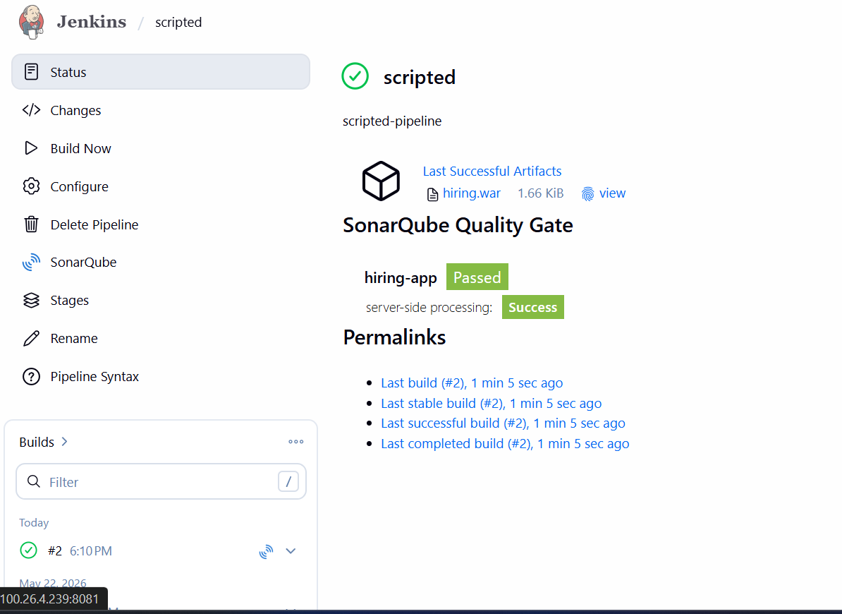
Check Console output
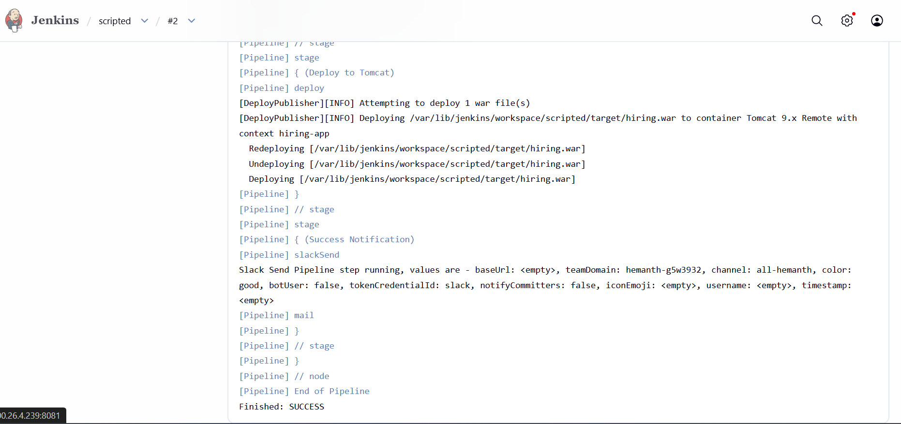
Slack notification
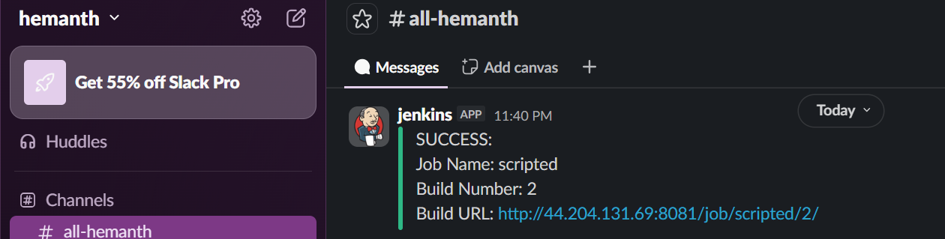
Email notification
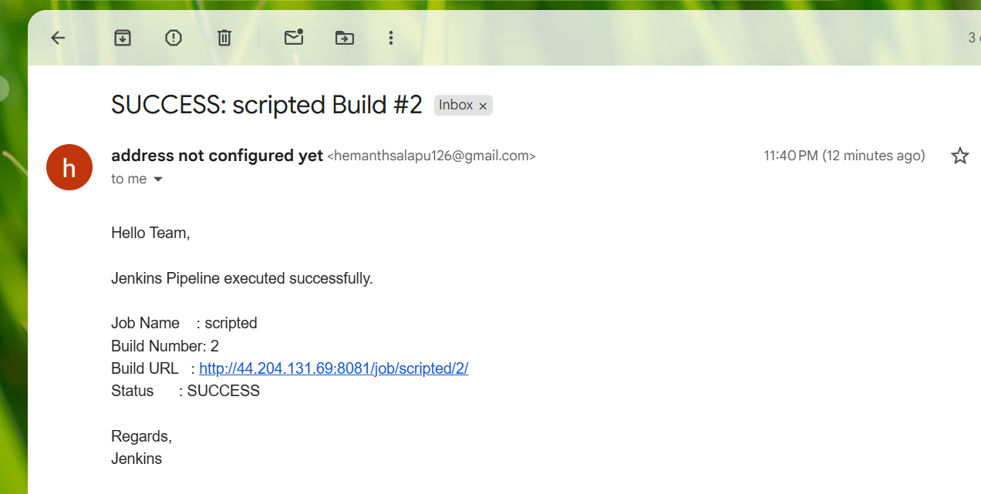
- Create one multi stage pipeline job
Create new item→select pipeline→save 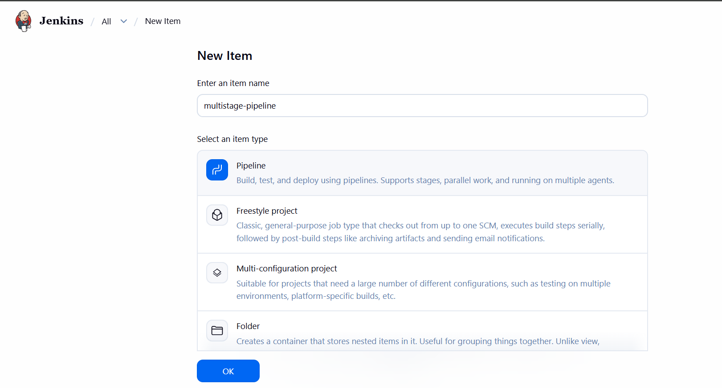
Open job→ click on configure →write pipeline →save& build
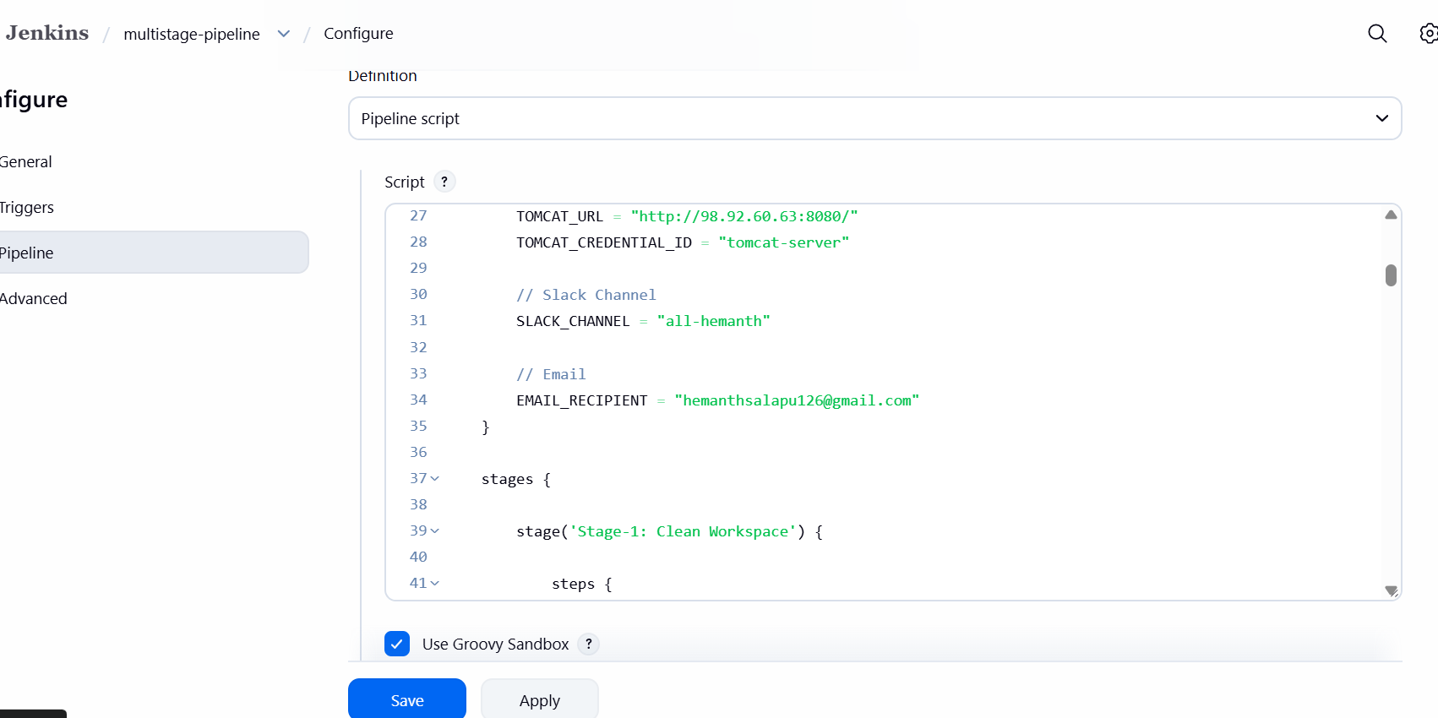
Used below script for pipeline
pipeline {

agent any

tools {
maven 'MVN_HOME'
}

environment {

// SonarQube
SCANNER_HOME = tool 'sonarQube-scanner'

// Nexus Details
NEXUS_VERSION = "nexus3"
NEXUS_PROTOCOL = "http"
NEXUS_URL = "44.222.89.164:8081"
NEXUS_REPOSITORY = "maven-new"
NEXUS_CREDENTIAL_ID = "nexus9"

// Artifact Details
GROUP_ID = "in.javahome"
ARTIFACT_ID = "hiring"
VERSION = "1.0.${BUILD_NUMBER}-SNAPSHOT"

// Tomcat Details
TOMCAT_URL = "http://98.92.60.63:8080/"
TOMCAT_CREDENTIAL_ID = "tomcat-server"

// Slack Channel
SLACK_CHANNEL = "all-hemanth"

// Email
EMAIL_RECIPIENT = "hemanthsalapu126@gmail.com"
}

stages {

stage('Stage-1: Clean Workspace') {

steps {

echo "Cleaning Jenkins Workspace..."

cleanWs()
}
}

stage('Stage-2: Clone Source Code') {

steps {

echo "Downloading Source Code from GitHub..."

git branch: 'main',
url: 'https://github.com/betawins/hiring-app.git'
}
}

stage('Stage-3: Build Application') {

steps {

echo "Building Application using Maven..."

sh "${tool 'MVN_HOME'}/bin/mvn clean install"
}
}

stage('Stage-4: Run Unit Tests') {

steps {

echo "Executing Maven Test Cases..."

sh 'mvn test'
}
}

stage('Stage-5: SonarQube Analysis') {

steps {

echo "Running SonarQube Code Analysis..."

withSonarQubeEnv('sonarQube') {

sh """
${SCANNER_HOME}/bin/sonar-scanner \
-Dsonar.projectKey=hiring-app \
-Dsonar.projectName=hiring-app \
-Dsonar.sources=.
"""
}
}
}

stage('Stage-6: Package Application') {

steps {

echo "Packaging WAR File..."

sh 'mvn clean package'
}
}

stage('Stage-7: Archive Artifact') {

steps {

echo "Archiving WAR Artifact..."

archiveArtifacts artifacts: 'target/hiring.war'
}
}

stage('Stage-8: Upload Artifact To Nexus') {

steps {

echo "Uploading WAR File to Nexus Repository..."

nexusArtifactUploader(

nexusVersion: NEXUS_VERSION,
protocol: NEXUS_PROTOCOL,
nexusUrl: NEXUS_URL,
repository: NEXUS_REPOSITORY,
credentialsId: NEXUS_CREDENTIAL_ID,
groupId: GROUP_ID,
version: VERSION,

artifacts: [
[
artifactId: ARTIFACT_ID,
classifier: '',
file: 'target/hiring.war',
type: 'war'
]
]
)
}
}

stage('Stage-9: Deploy Application To Tomcat') {

steps {

echo "Deploying WAR File to Tomcat Server..."

deploy adapters: [
tomcat9(
credentialsId: TOMCAT_CREDENTIAL_ID,
path: '',
url: "${TOMCAT_URL}"
)
],

contextPath: 'hiring-app',
war: 'target/hiring.war'
}
}
}

post {

success {

echo "Pipeline Executed Successfully"

// Slack Notification
slackSend(
channel: "${SLACK_CHANNEL}",
color: 'good',
message: """
✅ SUCCESS

Job Name : ${env.JOB_NAME}
Build Number : ${env.BUILD_NUMBER}
Build URL : ${env.BUILD_URL}
"""
)

// Email Notification
mail(
to: "${EMAIL_RECIPIENT}",
subject: "SUCCESS: ${env.JOB_NAME} Build #${env.BUILD_NUMBER}",
body: """
Hello Team,

Jenkins Pipeline executed successfully.

Job Name : ${env.JOB_NAME}
Build Number : ${env.BUILD_NUMBER}
Build URL : ${env.BUILD_URL}
Status : SUCCESS

Regards,
Jenkins
"""
)
}

failure {

echo "Pipeline Failed"

// Slack Notification
slackSend(
channel: "${SLACK_CHANNEL}",
color: 'danger',
message: """
❌ FAILURE

Job Name : ${env.JOB_NAME}
Build Number : ${env.BUILD_NUMBER}
Build URL : ${env.BUILD_URL}
"""
)

// Email Notification
mail(
to: "${EMAIL_RECIPIENT}",
subject: "FAILED: ${env.JOB_NAME} Build #${env.BUILD_NUMBER}",
body: """
Hello Team,

Jenkins Pipeline execution failed.

Job Name : ${env.JOB_NAME}
Build Number : ${env.BUILD_NUMBER}
Build URL : ${env.BUILD_URL}
Status : FAILURE

Please check Jenkins console logs.

Regards,
Jenkins
"""
)
}
}
}
Build successfully
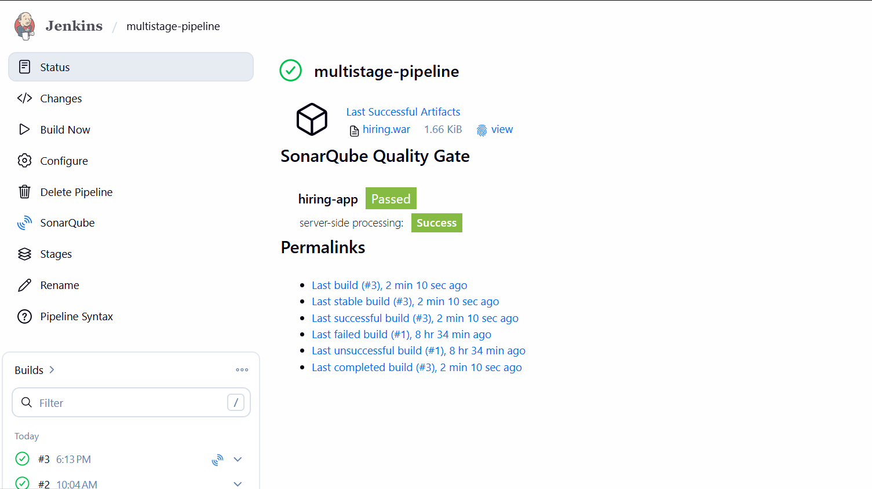
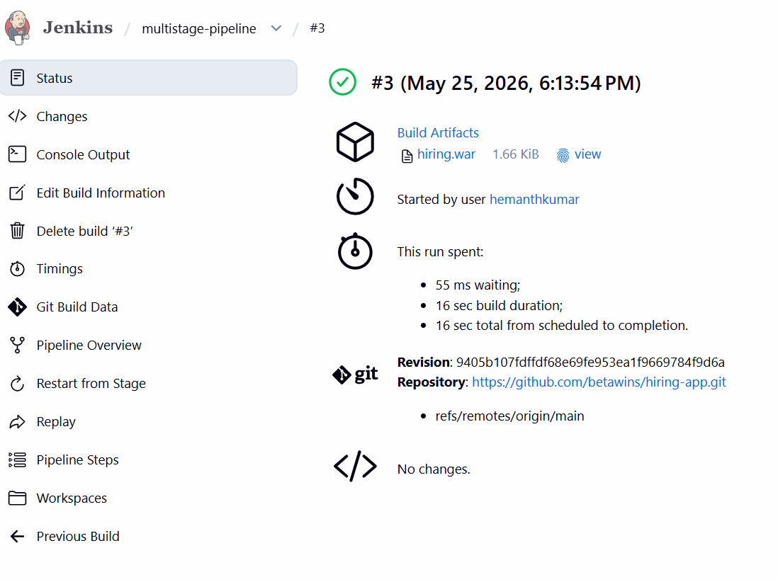
Check Console output
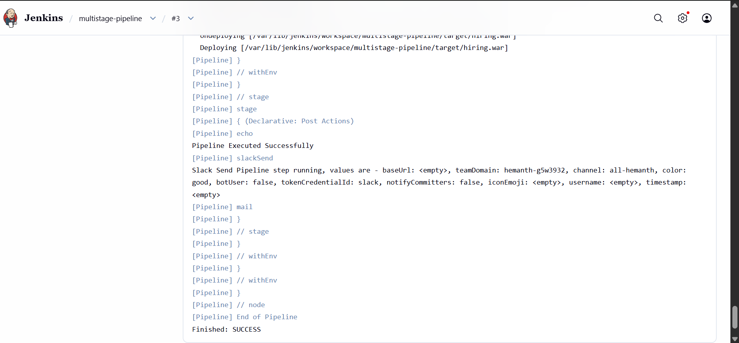
Slack notification
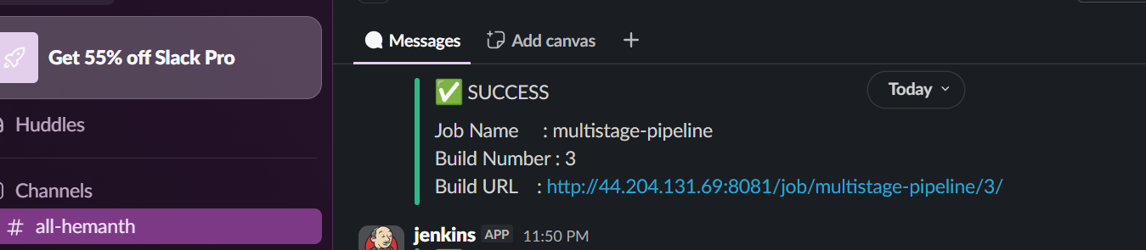
Email notification
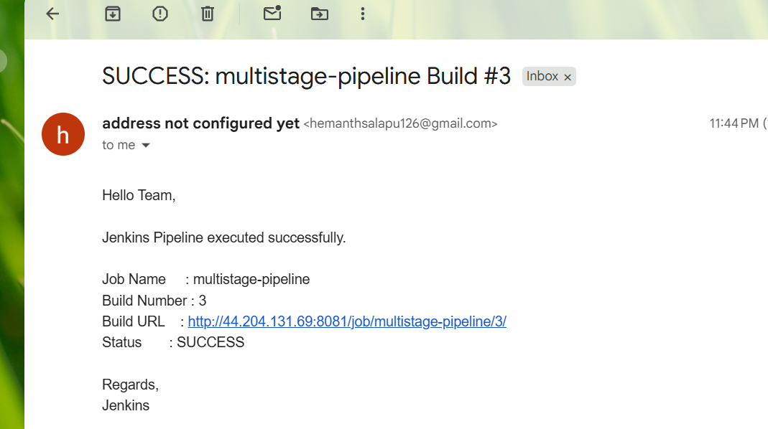
- Create one parallel stage pipeline job
Create new item →select pipeline →save
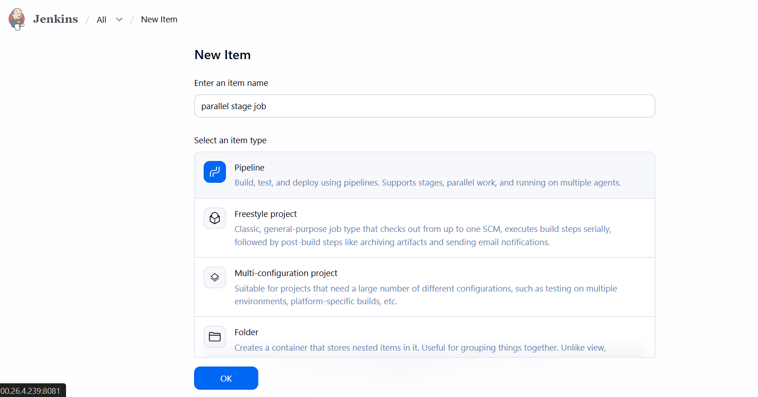
Open job→ click on configure →write pipeline →save& build
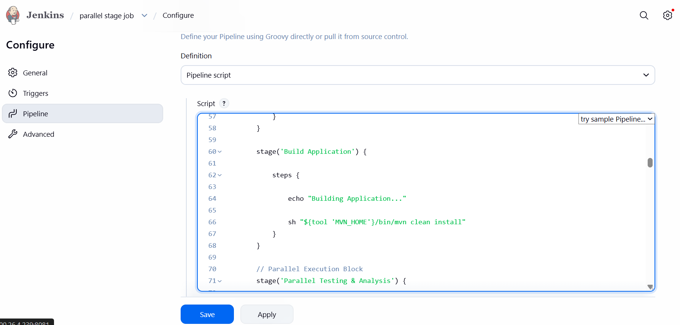
Used below script for pipeline
pipeline {

agent any

tools {
maven 'MVN_HOME'
}

environment {

// SonarQube
SCANNER_HOME = tool 'sonarQube-scanner'

// Nexus
NEXUS_VERSION = "nexus3"
NEXUS_PROTOCOL = "http"
NEXUS_URL = "44.222.89.164:8081"
NEXUS_REPOSITORY = "maven-new"
NEXUS_CREDENTIAL_ID = "nexus9"

// Artifact Details
GROUP_ID = "in.javahome"
ARTIFACT_ID = "hiring"
VERSION = "1.0.${BUILD_NUMBER}-SNAPSHOT"

// Tomcat
TOMCAT_URL = "http://98.92.60.63:8080/"
TOMCAT_CREDENTIAL_ID = "tomcat-server"

// Slack
SLACK_CHANNEL = "all-hemanth"

// Email
EMAIL_RECIPIENT = "hemanthsalapu126@gmail.com"
}

stages {

stage('Clean Workspace') {

steps {

echo "Cleaning Workspace..."

cleanWs()
}
}

stage('Clone Source Code') {

steps {

echo "Cloning Source Code..."

git branch: 'main',
url: 'https://github.com/betawins/hiring-app.git'
}
}

stage('Build Application') {

steps {

echo "Building Application..."

sh "${tool 'MVN_HOME'}/bin/mvn clean install"
}
}

// Parallel Execution Block
stage('Parallel Testing & Analysis') {

parallel {

stage('Run Unit Tests') {

steps {

echo "Executing Maven Tests..."

sh 'mvn test'
}
}

stage('SonarQube Code Analysis') {

steps {

echo "Running SonarQube Analysis..."

withSonarQubeEnv('sonarQube') {

sh """
${SCANNER_HOME}/bin/sonar-scanner \
-Dsonar.projectKey=hiring-app \
-Dsonar.projectName=hiring-app \
-Dsonar.sources=.
"""
}
}
}
}
}

stage('Package Application') {

steps {

echo "Packaging WAR File..."

sh 'mvn clean package'
}
}

// Parallel Artifact Operations
stage('Parallel Artifact Operations') {

parallel {

stage('Archive Artifact') {

steps {

echo "Archiving WAR Artifact..."

archiveArtifacts artifacts: 'target/hiring.war'
}
}

stage('Upload WAR to Nexus') {

steps {

echo "Uploading WAR to Nexus..."

nexusArtifactUploader(

nexusVersion: NEXUS_VERSION,
protocol: NEXUS_PROTOCOL,
nexusUrl: NEXUS_URL,
repository: NEXUS_REPOSITORY,
credentialsId: NEXUS_CREDENTIAL_ID,
groupId: GROUP_ID,
version: VERSION,

artifacts: [
[
artifactId: ARTIFACT_ID,
classifier: '',
file: 'target/hiring.war',
type: 'war'
]
]
)
}
}
}
}

stage('Deploy to Tomcat') {

steps {

echo "Deploying WAR to Tomcat..."

deploy adapters: [
tomcat9(
credentialsId: TOMCAT_CREDENTIAL_ID,
path: '',
url: "${TOMCAT_URL}"
)
],

contextPath: 'hiring-app',
war: 'target/hiring.war'
}
}
}

post {

success {

echo "Pipeline Executed Successfully"

// Slack Notification
slackSend(
channel: "${SLACK_CHANNEL}",
color: 'good',
message: """
✅ SUCCESS

Job Name : ${env.JOB_NAME}
Build Number : ${env.BUILD_NUMBER}
Build URL : ${env.BUILD_URL}
"""
)

// Email Notification
mail(
to: "${EMAIL_RECIPIENT}",
subject: "SUCCESS: ${env.JOB_NAME} Build #${env.BUILD_NUMBER}",
body: """
Hello Team,

Jenkins Pipeline executed successfully.

Job Name : ${env.JOB_NAME}
Build Number : ${env.BUILD_NUMBER}
Build URL : ${env.BUILD_URL}
Status : SUCCESS

Regards,
Jenkins
"""
)
}

failure {

echo "Pipeline Failed"

// Slack Notification
slackSend(
channel: "${SLACK_CHANNEL}",
color: 'danger',
message: """
❌ FAILURE

Job Name : ${env.JOB_NAME}
Build Number : ${env.BUILD_NUMBER}
Build URL : ${env.BUILD_URL}
"""
)

// Email Notification
mail(
to: "${EMAIL_RECIPIENT}",
subject: "FAILED: ${env.JOB_NAME} Build #${env.BUILD_NUMBER}",
body: """
Hello Team,

Jenkins Pipeline execution failed.

Job Name : ${env.JOB_NAME}
Build Number : ${env.BUILD_NUMBER}
Build URL : ${env.BUILD_URL}
Status : FAILURE

Please check Jenkins console logs.

Regards,
Jenkins
"""
)
}
}
}
Build successfully
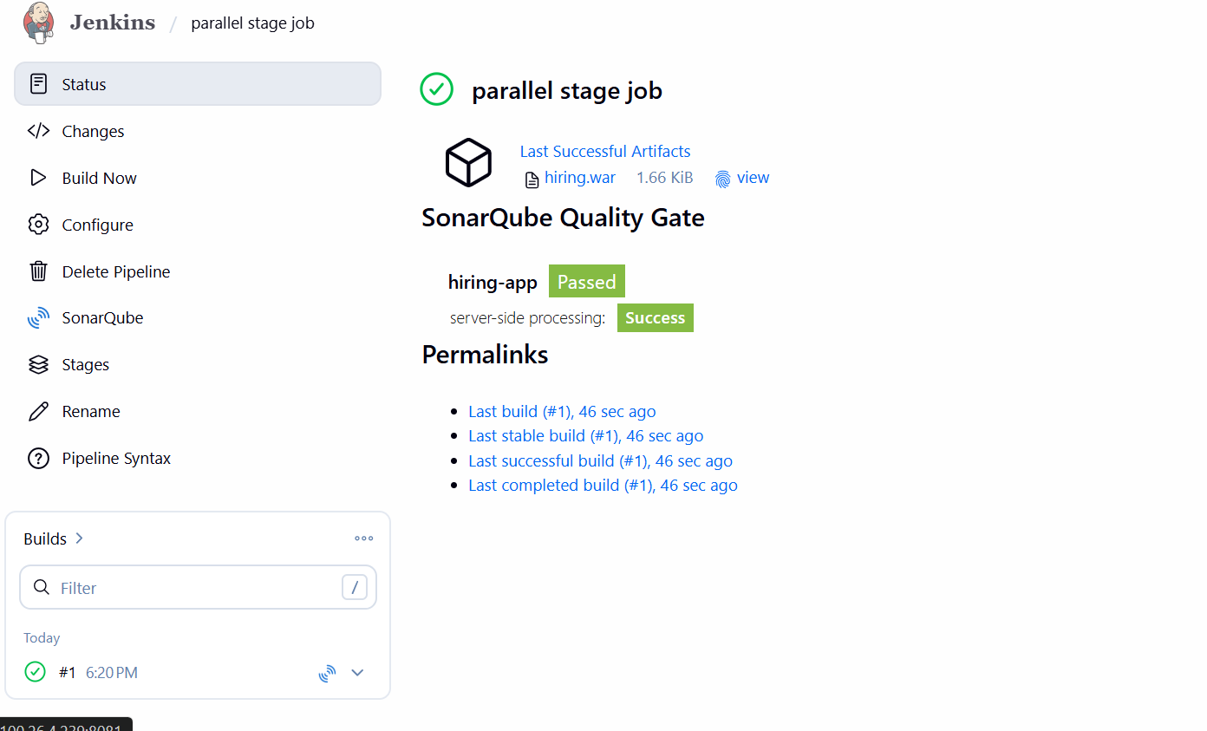
Check Console output
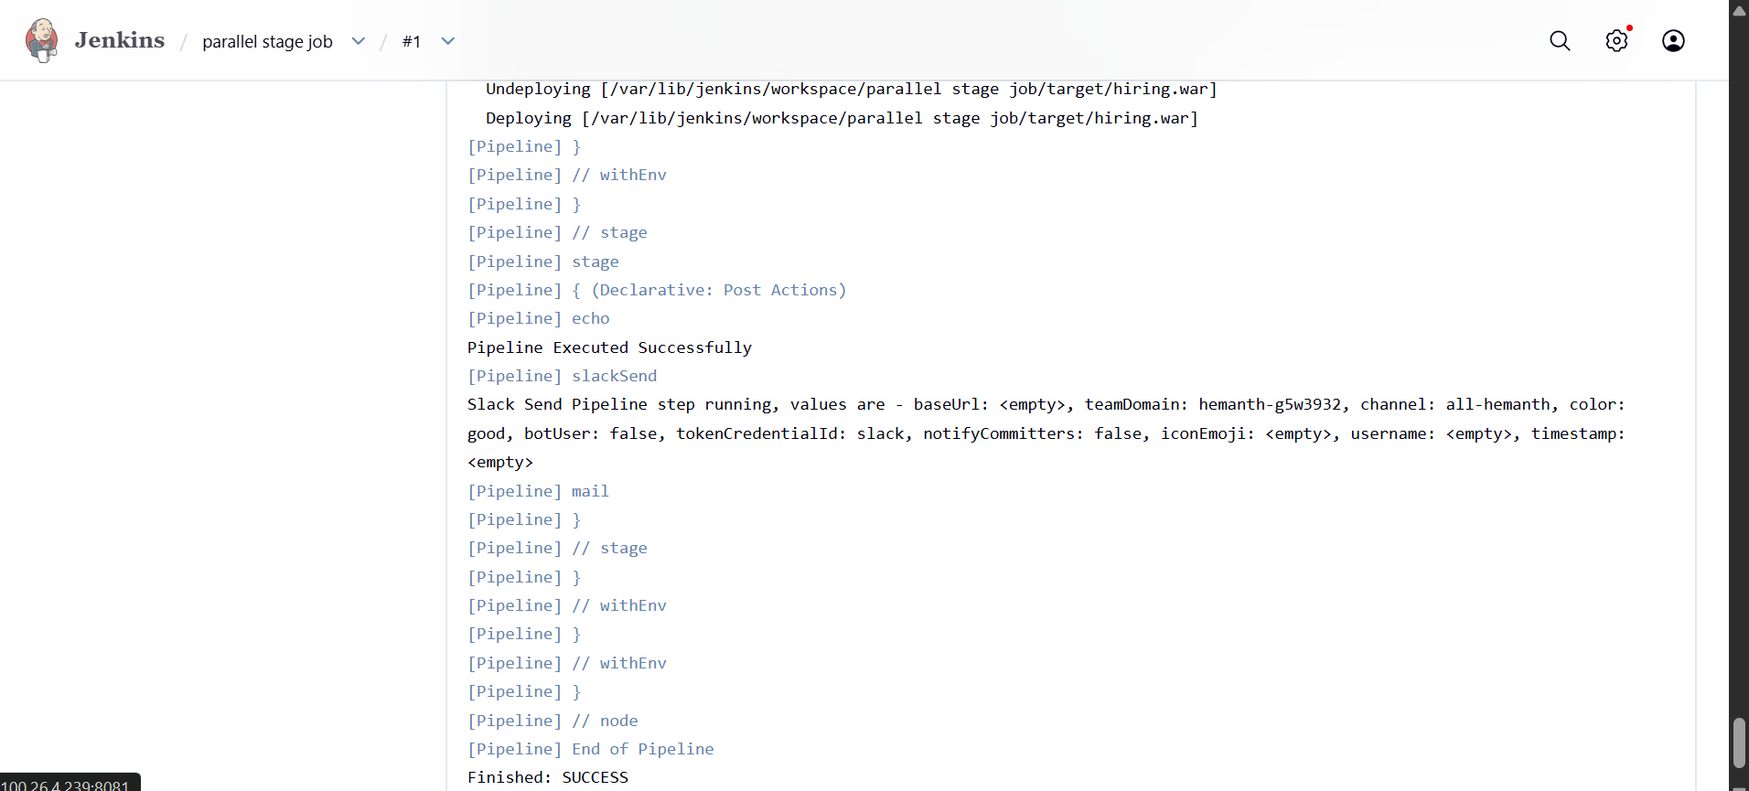
Slack notification
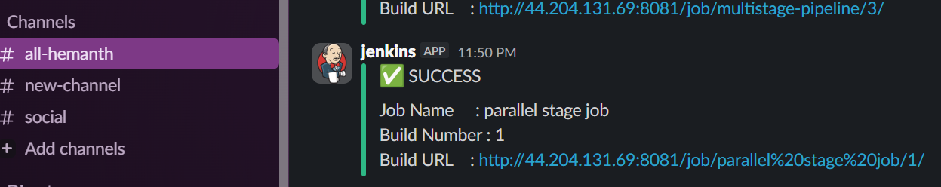
Email notification

